Test Case: runTestMultipleTimes
Step 1 - Enter username and password and click to button Enter : Credentials Entered
Image file-name: QC_Testing-runTestMultipleTimes-dic. 03 2025, 09 22 28 a. m.

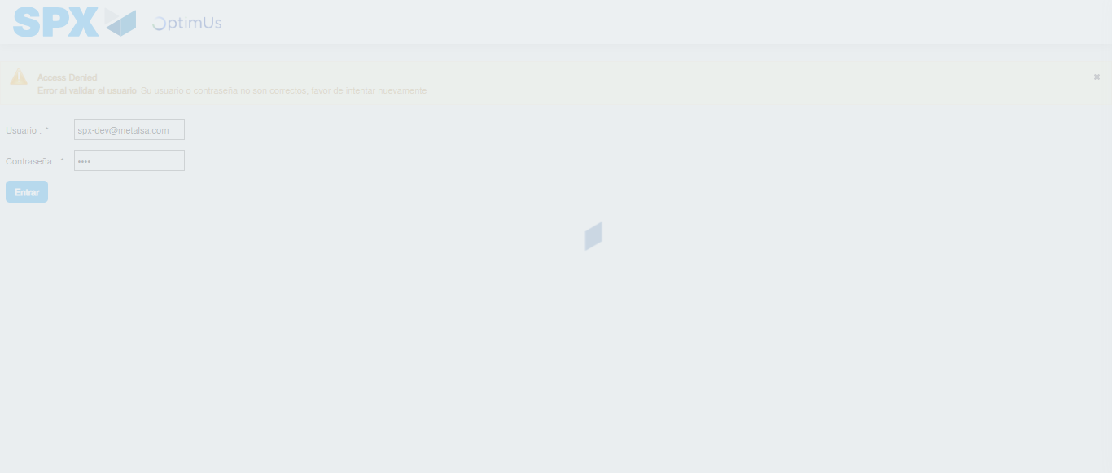Image file-name: QC_Testing-runTestMultipleTimes-dic. 03 2025, 09 22 29 a. m.

Step 2 - Select to UEN and Access to Administrador Roles Menu: UEN Correctly selected and Correct access
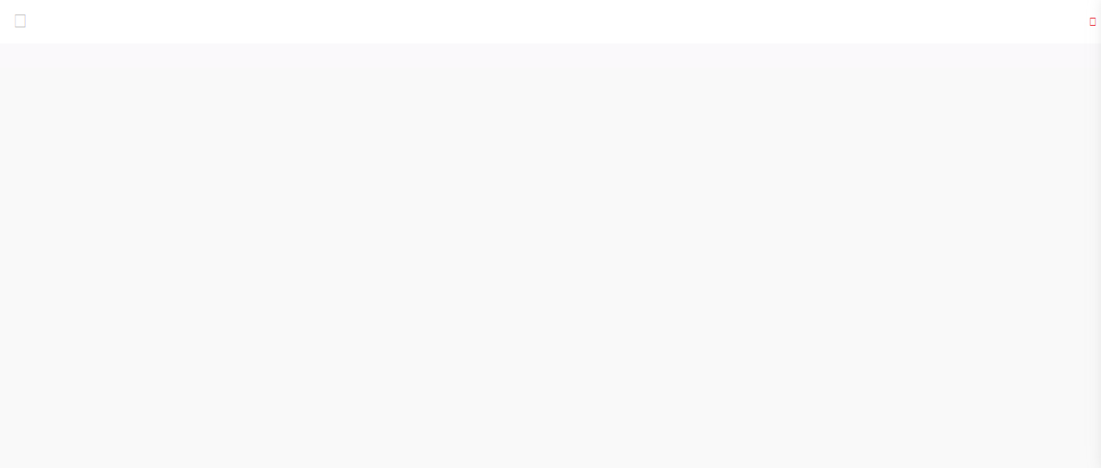Image file-name: QC_Testing-runTestMultipleTimes-dic. 03 2025, 09 22 34 a. m.

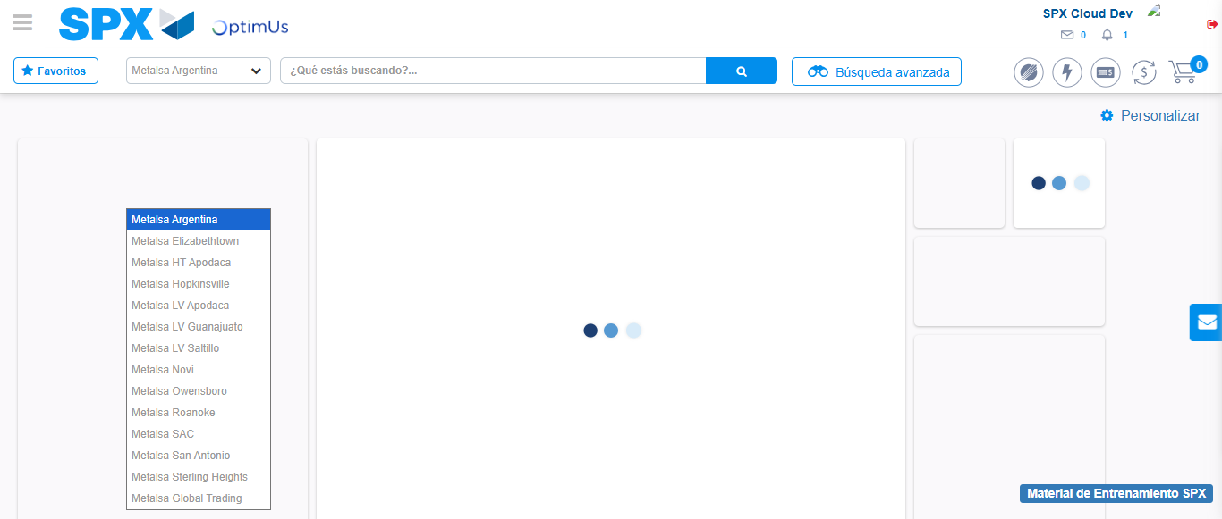Image file-name: QC_Testing-runTestMultipleTimes-dic. 03 2025, 09 22 35 a. m.

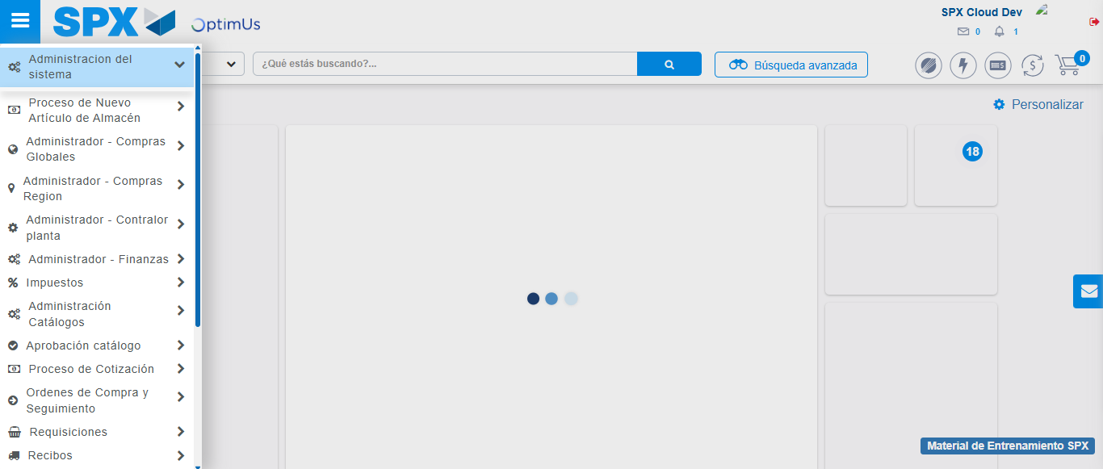Image file-name: QC_Testing-runTestMultipleTimes-dic. 03 2025, 09 22 36 a. m.

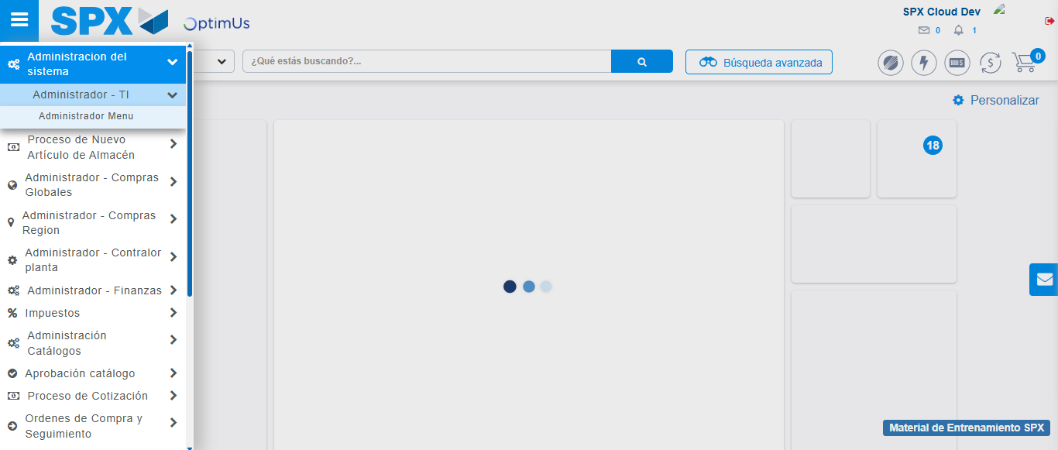Image file-name: QC_Testing-runTestMultipleTimes-dic. 03 2025, 09 22 37 a. m.

Image file-name: QC_Testing-runTestMultipleTimes-dic. 03 2025, 09 22 42 a. m.

Step 3 - Click to Buttons View Menu and Search Filter with Menu Name: Correct Search
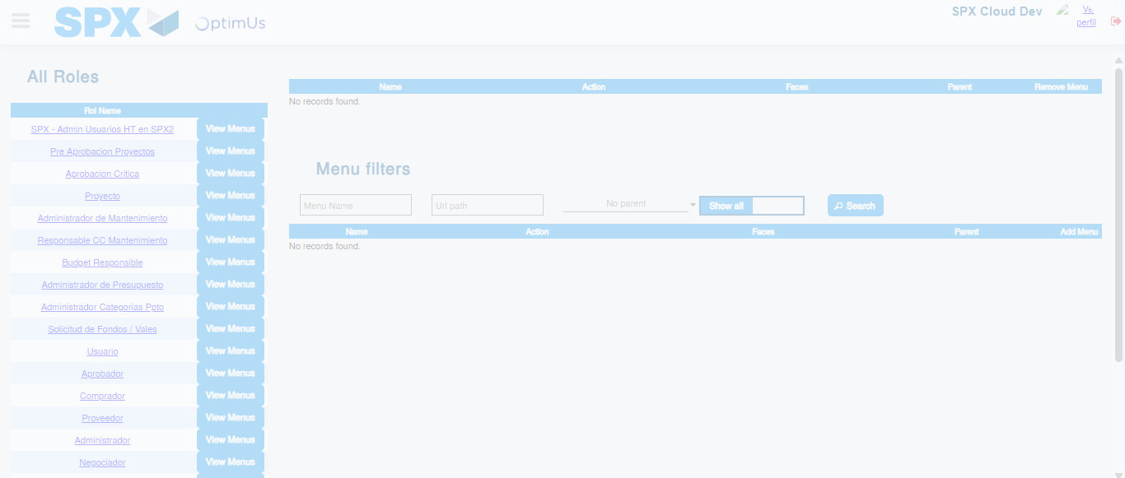Image file-name: QC_Testing-runTestMultipleTimes-dic. 03 2025, 09 22 43 a. m.

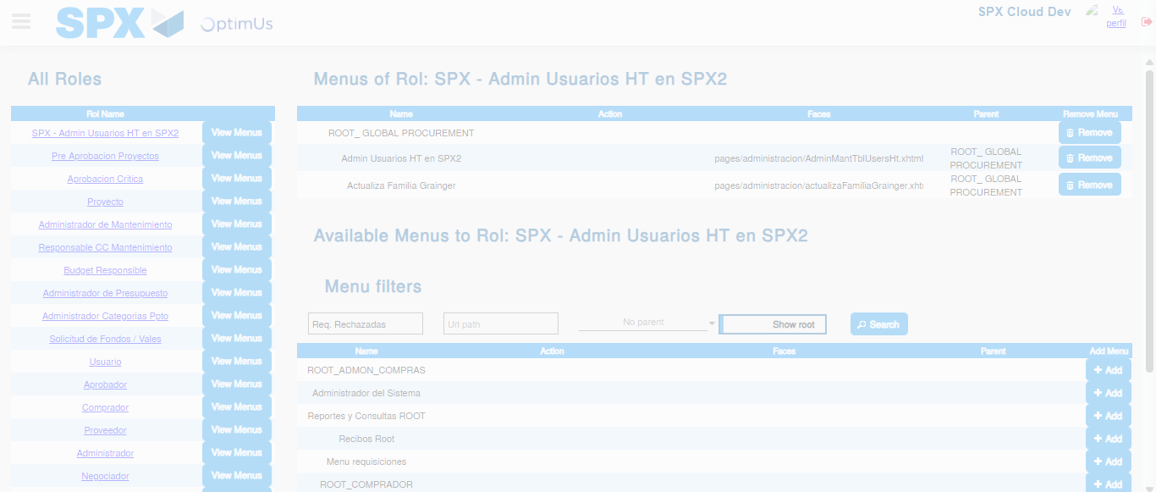Image file-name: QC_Testing-runTestMultipleTimes-dic. 03 2025, 09 22 44 a. m.

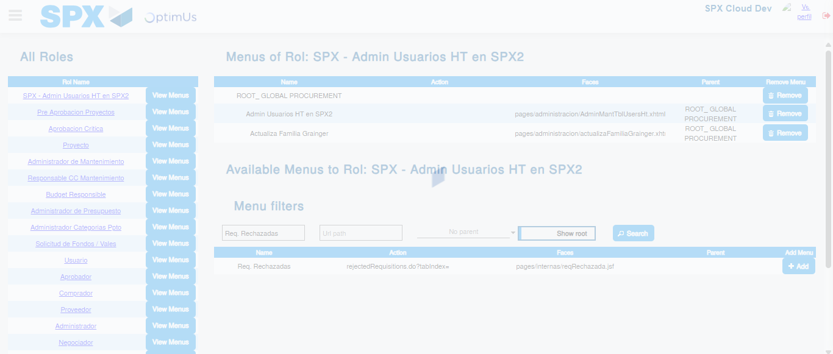Image file-name: QC_Testing-runTestMultipleTimes-dic. 03 2025, 09 22 45 a. m.

